<GGE300> METRICS REPORT

Contents

1. Project Introduction 2

2. Schedule Variance and cost Variance 2

2.1. EVMS CHART 2

2.2. Causal Analysis(Phase wise) 4

2.3. Corrective Actions 5

3. Product Defect Density 5

3.1. Corrective Actions 5

3.2. Root Cause Analysis 5

4. Project’s Process Defect Density 5

4.1. Corrective Actions 5

4.2. Root Cause Analysis 6

# Project Introduction

Project Manager: Syoji Ram Sharma

Team Size :10 Nos

# Schedule Variance and cost Variance

## EVMS CHART

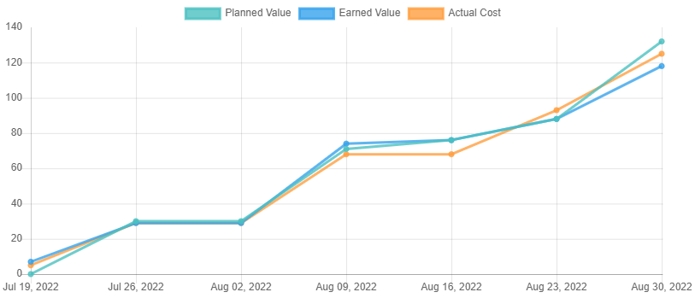

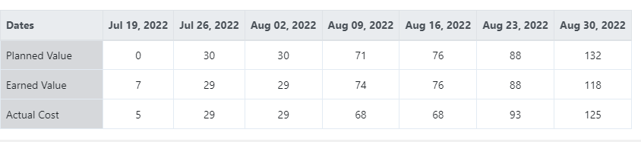

**Schedule and Cost Variance analysis at project Level**

|  |  |  |  |  |  |  |  |
| --- | --- | --- | --- | --- | --- | --- | --- |
| Weeks | No of Week | Name of Phase | Planned Value | Earned Value | Actual Cost | Schedule variance  (EV-PV/PV)*100 | Cost Variance  (AC-EV/EV)*100 |
| 1st | 19-07-22 to 26-07-22 | RD Phase, Planning Phase | 30 | 29 | 29 | -3.33% | 0% |
| 2nd | 26-07-22 to 02-08-22 | Planning Phase | 30 | 29 | 29 | -3.33% | 0% |
| 3rd | 02-08-22 to 09-08-22 | Design and Implementation | 71 | 74 | 68 | 4.22% | -8.10% |
| 4th | 09-08-22 to 16-08-22 | Testing and integration | 76 | 76 | 68 | 0% | -10.52% |
| 5th | 16-08-22 to 23-08-22 | Testing and integration | 88 | 88 | 93 | 0% | 5.68% |
| 6th | 23-08-22 to 30-08-22 | Validation Phase , Closure | 132 | 118 | 125 | -10.60% | 5.59% |

**Schedule and Effort Variance analysis at Weekly time slot with phase wise**

|  |  |  |  |  |  |  |  |
| --- | --- | --- | --- | --- | --- | --- | --- |
| Weeks | No of Week | Name of Phase | Planned Value | Earned Value | Actual Cost | Schedule variance  (EV-PV/PV)*100 | Cost Variance  (AC-EV/EV)*100 |
| 1st | 19-07-22 to 26-07-22 | RD Phase, Planning Phase | 30 | 30 | 29 | 0% | -3.33% |
| 2nd | 26-07-22 to 02-08-22 | Planning Phase | 0 | 0 | 0 | 0% | 0% |
| 3rd | 02-08-22 to 09-08-22 | Design and Implementation | 41 | 45 | 39 | 8.88% | -13.3% |
| 4th | 09-08-22 to 16-08-22 | Testing and integration | 5 | 2 | 0 | -60% | -100% |
| 5th | 16-08-22 to 23-08-22 | Testing and integration | 12 | 12 | 25 | 0% | 100% |
| 6th | 23-08-22 to 30-08-22 | Validation Phase , Closure | 44 | 30 | 32 | -31.81% | 6.66% |

## Causal Analysis(Phase wise)

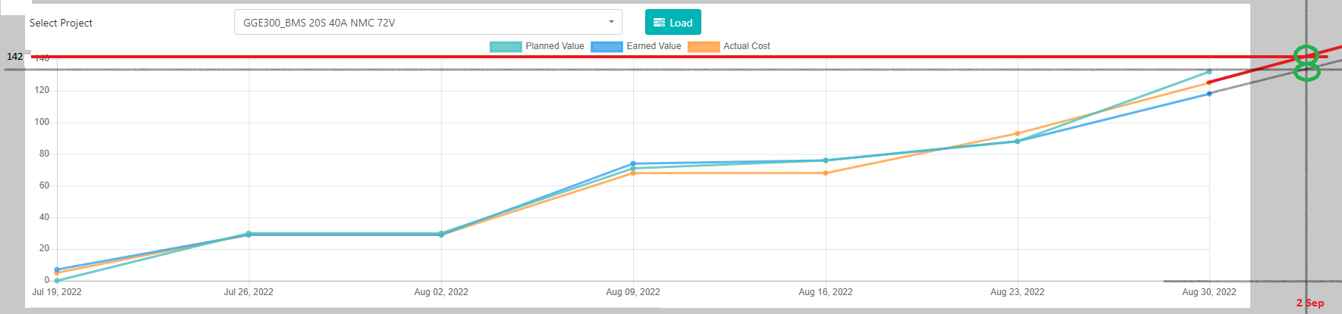

**Schedule and Effort Variance analysis at project Level**

|  |  |  |  |  |  |  |  |
| --- | --- | --- | --- | --- | --- | --- | --- |
| Weeks | No of Week | Name of Phase | Planned Value | Earned Value | Actual Cost | Schedule variance  (EV-PV/PV)*100 | Cost Variance  (EV-AC/EV)*100 |
| 1st | 19-07-22 to 26-07-22 | RD Phase, Planning Phase | 30 | 29 | 29 | -3.33% | 0% |
| 2nd | 26-07-22 to 02-08-22 | Planning Phase | 30 | 29 | 29 | -3.33% | 0% |
| 3rd | 02-08-22 to 09-08-22 | Design and Implementation | 71 | 74 | 68 | 4.22% | -8.10% |
| 4th | 09-08-22 to 16-08-22 | Testing and integration | 76 | 76 | 68 | 0% | -10.52% |
| 5th | 16-08-22 to 23-08-22 | Testing and integration | 88 | 88 | 93 | 0% | 5.68% |
| 6th | 23-08-22 to 30-08-22 | Validation Phase , Closure | 132 | 118 | 125 | -10.60% | 5.59% |
| 7th | 30-8-22 to 3-09-22 | Closure | 132 | 132 | 142 | 0% | 7.57% |

The schedule variance found -10.60% in negative side , we will achieve target of this phase after time and got variance in under limit.

The Cost variance found 7.57% in positive side , we will achieve target in 142 person hours after the schedule time and got variance in under limit.

## Corrective Actions

Not Required.

**The overall schedule variance : As total planned value was 132 at on date 31 Aug 2022 and we will cover up to 2 Sep. so overall schedule variance is -10.60%, which is under limit of our measurement goal.**

**The overall cost variance : As total planned value was 132 at on date 31 Aug 2022 and we will cover it up to 142. so overall cost variance is 7.57%, which is under limit of our measurement goal.**

# Product Defect Density

The product defect density found 0.015, whereas measurement goal was 0.10±0.02. So it is little bit out of limit in lower side. The total efforts expended on this project is 132 person hrs. This means that in every 66 person hrs one functional defect came in this project.

## Corrective Actions

Not required

## Root Cause Analysis

Not required

# Project’s Process Defect Density

The process defect density found 0.28 whereas measurement goal was 0.20±0.03. So it is equal to limit. The total efforts expended on this project is 132 persons hrs. This means that in every 3.47 person hrs one major non conformance came in this project. That is equal to near expected.

## Corrective Actions

As this defect density documented during closure so corrective actions not applicable for this particular projet, but may help to future projects. But in this project I monitored the process defect density, and try to not leave any blunder in process point of view, as previous project learnings also usefull. During updation of RTT ensure that each and every needs track by something in design, implementation, testing, no any system test case id missing to link with needs. Now as organization goal decided for process defect density as 0.20±0.02, so in next project will plan accordingly.

## Root Cause Analysis

Most of NCs main cause observed is negligence during planning updation, timesheet missing, negligence during RTT updation, so some of silly mistakes done, which actually effects more.

**Date :**

[31/08/2022]